Superstore Sales & Customer Segmentation Report

Executive Summary
This report analyzes Superstore's historical sales data to identify key revenue drivers, assess customer behavior, and uncover opportunities for growth. The analysis focuses on overall sales trends, category performance, and a detailed behavioral segmentation of the customer base.

1. High-Level Performance
The dataset provides a comprehensive view of Superstore's performance across 9,800 transactional line items.
Key Performance Indicators (KPIs):
- Total Revenue (Sales): $2,261,536.78
- Total Unique Orders: 4,922
- Total Unique Customers: 793
- Average Order Value (AOV): ~$459.48 (Calculated as Total Revenue / Total Unique Orders)
Insight: The business has a solid customer base with a healthy average order value. However, further analysis is needed to understand the distribution of this revenue across segments and product lines.

2. Sales Trends & Seasonality
Understanding when sales happen is critical for inventory planning and marketing allocation.
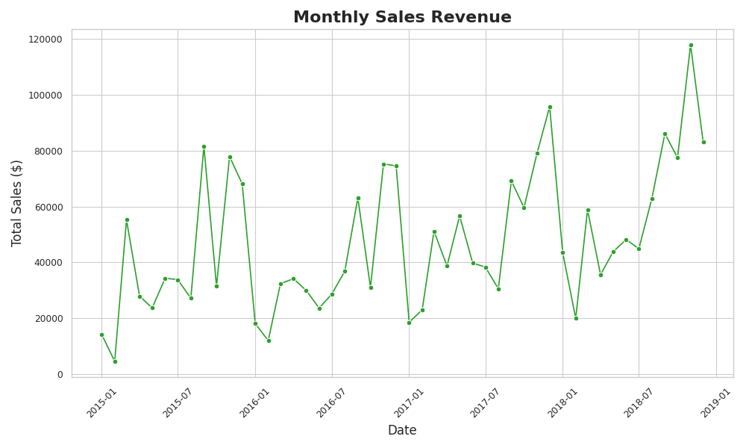
- Visualization: A line chart displaying total monthly sales revenue from the earliest to the latest date in the dataset.
Key Findings:
- End-of-Year Spikes: The data exhibits significant seasonality, with massive revenue spikes occurring consistently toward the end of each year (typically November and December).
- Actionable Takeaway: Marketing budgets and inventory stockpiling should be heavily front-loaded in Q3 to capitalize on this predictable Q4 surge.

3. Revenue Drivers by Category and Segment
To optimize the product mix, we must look at what is selling and who is buying it.
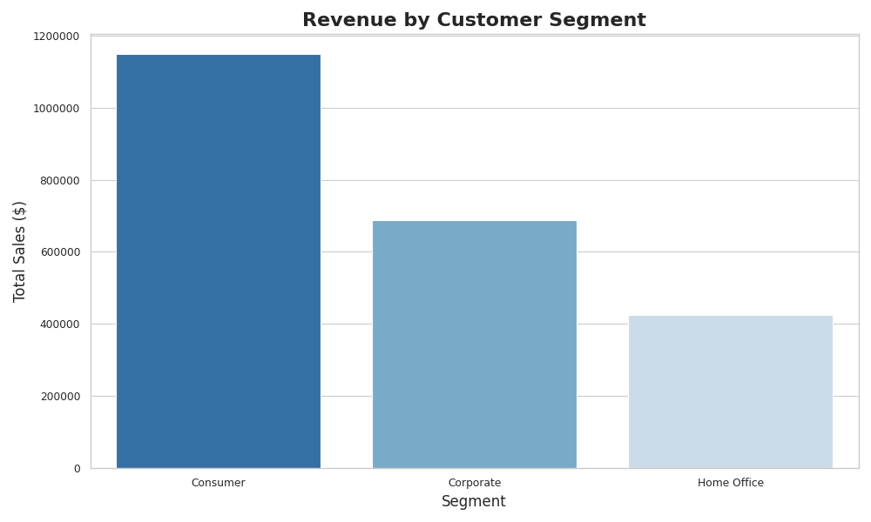
- Visualization: A bar chart comparing total revenue across the three customer segments (Consumer, Corporate, Home Office).
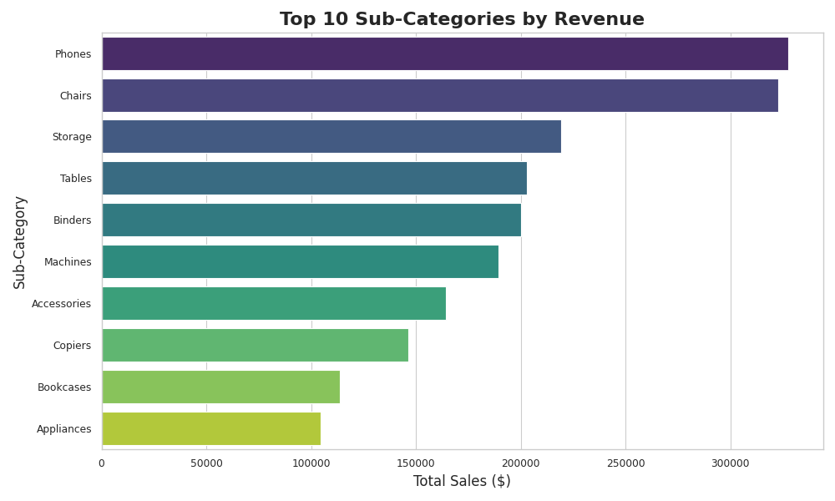
- Visualization: A horizontal bar chart showing the Top 10 sub-categories ranked by total revenue.
Key Findings:
- The "Consumer" Dominance: The 'Consumer' segment is the primary revenue engine, driving significantly more sales than 'Corporate' or 'Home Office'.
- Top Sub-Categories: 'Phones' and 'Chairs' are the runaway leaders in revenue generation.
- Actionable Takeaway: While 'Phones' and 'Chairs' drive top-line revenue, these are often high-cost items. Superstore should ensure these categories are maintaining healthy profit margins and are not being overly discounted to drive volume.

4. Customer Behavioral Segmentation (RFM Analysis)
We utilized RFM (Recency, Frequency, Monetary value) analysis to grade every individual customer based on their purchasing behavior. Customers were scored on how recently they bought, how often they buy, and how much they spend, resulting in four key segments.
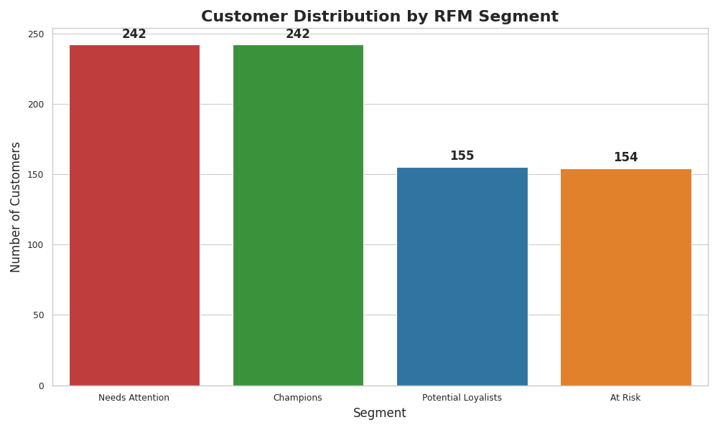
- Visualization: A bar chart showing the count of customers falling into each of the four RFM segments (Champions, Potential Loyalists, At Risk, Needs Attention).
Key Findings:
- Strong Champion Base: We have 242 "Champions" (customers who buy recently, frequently, and spend the most). These are the most valuable customers.
- The "At Risk" Segment: Alarmingly, there are 154 customers categorized as "At Risk" (high historical spend and frequency, but haven't purchased recently).
- The "Needs Attention" Segment: 242 customers fall into this category, meaning they buy infrequently and haven't bought recently.
Actionable Takeaways & Strategy:
- Win-Back Campaign: The immediate priority is the 154 "At Risk" customers. A targeted marketing campaign (e.g., "We Miss You" high-value discount codes) should be deployed immediately to re-engage them before they churn completely.
- Reward Champions: The 242 "Champions" should be enrolled in a loyalty or VIP program to maintain their high engagement and encourage word-of-mouth referrals.
- Nurture Potential Loyalists: The 155 "Potential Loyalists" need to be incentivized to increase their frequency. Cross-selling related products based on their initial purchases (e.g., offering 'Binders' or 'Accessories' to those who bought 'Phones') is a solid next step.

